**Hotel Booking Application**

**(Web application)**

**A PROJECT REPORT**

**For**

**Mini Project (KCA353)**

**Session (2023-24)**

**Submitted by**

**Deepanshi Sharma**

**2200290140052**

**Kajal Kushwaha**

**2200290140077**

**Submitted in partial fulfilment of the**

**Requirements for the Degree of**

**MASTER OF COMPUTER APPLICATION**

**Under the Supervision of**

**Mrs. Shalika Mam**

### Assistant Professor



**Submitted to**

**Department Of Computer Applications**

**KIET Group of Institutions, Ghaziabad**

**Uttar Pradesh-201206**

**(FEBRUARY 2024)**

**DECLARATION**

I hereby declare that the work presented in report entitled “Hotel Booking Application” was carried out by me. I have not submitted the matter embodied in this report for the award of any other degree or diploma of any other University of Institute. I have given due credit to the original authors/sources for all the words, ideas, diagrams, graphics, computer programs, that are not my original contribution. I have used quotation marks to identify verbatim sentences and give credit to the original authors/sources. I affirm that no portion of my work is plagiarized, and the experiments and results reported in the report are not manipulated. In the event of a complaint of plagiarism and the manipulation of the experiments and results, I shall be fully responsible and answerable.

**Name:** Deepanshi Sharma

**Roll No.:** 2200290140052

**Name:** Kajal Kushwaha

**Roll No.:** 2200290140077

## **(Candidate Signature)**

**CERTIFICATE**

Certified that **Deepanshi Sharma 2200290140052, Kajal Kushwaha 2200290140077** has/ have carried out the project work having “**Hotel Booking Application**” (**Mini Project-KCA353**) for **Master of Computer Application** from Dr. A.P.J. Abdul Kalam Technical University (AKTU**)** (formerly UPTU), Lucknow under my supervision. The project report embodies original work, and studies are carried out by the student himself/herself and the contents of the project report do not form the basis for the award of any other degree to the candidate or to anybody else from this or any other University/Institution.

**Date:14/01/2024**

**Deepanshi Sharma (2200290140052)**

**Kajal Kushwaha (2200290140077)**

This is to certify that the above statement made by the candidate is correct to the best of my knowledge.

**Date: 14/01/2024**

**Ms. Shalika Mam Dr. Arun Tripathi**

**Assistant Professor Head**

**Department of Computer Applications Department of Computer Applications**

**KIET Group of Institutions, Ghaziabad DKIET Group of Institutions, Ghaziabad**

**ABSTRACT**

The Hotel Booking Application is a user-friendly web application designed to simplify the hotel reservation process for travellers. In today's fast-paced world, where convenience and efficiency are paramount, this web application provides an intuitive platform for users to effortlessly discover, book, and manage their accommodations. This abstract provides an overview of the key features and benefits of the hotel booking app.

A sleek and intuitive design that allows users to easily search for hotels, view room options, and make reservations. The primary objective of the Hotel Booking App is to provide travellers with a seamless and personalized experience when searching for and booking hotels.

In conclusion, the Hotel Booking application offers a modern and efficient solution for travellers seeking convenient and hassle-free hotel reservations. By combining cutting-edge technology with a user-centric design, this app aims to enhance the travel planning process, ensuring that users find the perfect accommodations for their needs while enjoying a seamless booking experience on their mobile devices.

**ACKNOWLEDGEMENT**

Success in life is never attained single handedly. My deepest gratitude goes to my thesis supervisor, Mrs. Shalika Mam (Assistant Professor) for their guidance, help and encouragement throughout my project work. Their enlightening ideas, comments, and suggestions have guided me a lot in completing this project successfully.

Words are not enough to express my gratitude to Dr. Arun Kumar Tripathi, Professor and Head, Department of Computer Applications, for his insightful comments and administrative help at various occasions. Fortunately, I have many understanding friends, who have helped me a lot on many critical conditions.

Finally, my sincere thanks go to my family members and all those who have directly and indirectly provided me moral support and other kind of help. Without their support, completion of this work would not have been possible in time. They keep my life filled with enjoyment and happiness.

Deepanshi Sharma (2200290140052)

Kajal Kushwaha (2200290140077)

|  |  |
| --- | --- |
| **TABLE OF CONTENTS** |  |
| Declaration | **Page No.**  ii |
| Certificate | iii |
| Abstract | iv |
| Acknowledgements | v |
| Table of contents | vi |
| List of tables | viii |
| List of figures | ix |
|  |  |
| Chapter 1: Introduction | 10-12 |
| 1.1 Overview | 10 |
| 1.2 Functionality | 10 |
| 1.3 Objectives | 10 |
| 1.4 Scope | 11 |
| 1.5 Hardware / Software used in project | 12 |
| Chapter 2: Feasibility Study | 13-14 |
| 2.1 Technical feasibility | 13 |
| 2.2 Operational feasibility | 13 |
| 2.3 Economic feasibility | 13 |
| 2.4 Behavioural feasibility | 14 |
| Chapter 3: System requirements | 15-16 |
| 3.1 Functional requirements | 15 |
| 3.2 Non-functional requirements | 16 |
|  |  |
| Chapter 4: System Analysis | 17-18 |
| 4.1 Current System Analysis | 17 |
| 4.2 Proposed System enhancement | 18 |
| Chapter 5: System Design | 19-25 |
| 5.1 Technical feasibility | 19 |
| 5.2 Secondary design phase | 19 |
| 5.3 Use case diagram | 20 |
| 5.4 ER Diagram | 21 |
| 5.5 Data Flow Diagram | 22-24 |
| 5.5.1 Level-0 DFD | 22 |
| 5.5.2 Level-1 DFD | 23 |
| 5.5.3 Level-3 DFD | 24 |
| 5.6 Design Goals | 25 |
|  |  |
| Chapter 6: Testing | 26-27 |
| 6.1 Testing | 26 |
| 6.2 Testing result | 27 |
| Chapter 7: Conclusion | 37 |
| 7.1 Future enhancement | 37 |
|  |  |
| Chapter 8: References | 38 |
|  |  |

**LIST OF TABLE**

|  |  |  |
| --- | --- | --- |
| **Table No.** | **Name of Table** | **Page** |
| 1.1 | Hardware Requirement | 11 |
| 1.2 | Software Requirement | 12 |
|  |  |  |
|  |  |  |
|  |  |  |
|  |  |  |

**LIST OF FIGURE**

|  |  |  |  |
| --- | --- | --- | --- |
| **Figure No.** | **Name of Figure** | **Page No.** | |
| 5.1 | Use case diagram | | 20 | |
| 5.2 | ER- diagram | | 21 | |
| 5.3 | Level 0 DFD Diagram | | 22 | |
| 5.4 | Level 1 DFD Diagram | | 23 | |
| 5.5 | Level 2 DFD Diagram | | 24 | |
| 7.1 | Home Page | | 28 | |
| 7.2 | Login Page | | 29 | |
| 7.3 | Sign up Page | | 30 | |
| 7.4 | Room Availability Checking Page | | 31 | |
| 7.5 | Available Room Page | | 32 | |
| 7.6 | Booking Page | | 34 | |
| 7.7 | Admin Login Page | | 35 | |
| 7.8 | Food Page | | 36 | |
| 7.9 | Food add to cart Page | | 36 | |

**Chapter 1**

**INTRODUCTION**

* 1. **Overview**

The Hotel Booking Application is a project implemented for Star Hotel, which is an imaginary hotel. It provides people all Over the world with an easy and fast way to book hotel rooms online. The interface of the Hotel Booking Application is Web pages that can be accessed with a Web site browser. The system is implemented in PHP (Hypertext Preprocessor) and HTML (Hyper Text Markup Language). Users can perform room booking activities at Star Hotel anytime and anywhere by accessing it via the Internet. The Hotel Booking Application is an easy-to-use application. Everyone who knows how to use a Web browser can easily carry out booking, change the booking details, cancel the booking, view the hotel information by following its simple and clear GUI (Graphical user interface) design.

### 1.2 FUNCTIONALITY

* Users can book a room on any specific date.
* Users can check the room availability at Star Hotel before they book a room.
* Administrators can change the quantity and price on all four types of rooms.
* Administrators can change any specific booking details.
* Administrators can cancel any specific booking.
* Administrators can modify the details of static pages including room information, information about us, contact us information, customer service Q&A details, local travel and shipping guide, and privacy policy after login.

**1.3 OBJECTIVES**

* Simplify the booking process
* Provide a user-friendly interface
* Integrate with existing hotel systems
* Improve booking management efficiency
* Enhance the overall customer experience

**1.4 SCOPE**

It may help collecting perfect management in details. In a very short time, the collection will be obvious, simple, and sensible. It will help a person to know the management of passed year perfectly and vividly. It also helps in current all works relative to Hotel Booking System. It will be also reduced the cost of collecting the management & collection procedure will go on smoothly.

Our project aims at Business process automation, i.e. we have tried to computerize various processes of Hotel Booking Application.

* Web-based application for desktop and mobile
* Integration with existing hotel systems
* Secure payment gateway
* Testing and quality assurance
* Staff training
  1. **Hardware / Software Requirement**

Hardware Requirement

|  |  |
| --- | --- |
| **S. N.** | **Description** |
| 1 | PC with 5 GB or more Hard disk. |
| 2 | PC with 2 GB RAM. |
| 3 | PC with core i3 or above processor. |

Software Requirements

|  |  |  |
| --- | --- | --- |
| **S. N.** | **Description** | **Type** |
| 1 | Operating System | Windows 10 or 11 or  Ubuntu 18.04 or above |
| 2 | Language | JavaScript |
| 3 | Front End | React 17 |
| 4 | IDE | Google Colab, VS Code |
| 5 | Browser | Chrome, Firefox, Edge |

**CHAPTER 2**

**FEASIBILITY STUDY**

After doing the project Hotel Booking System, study and analyzing all the existing or required functionalities of the system, the next task is to do the feasibility study for the project. All projects are feasible - given unlimited resources and infinite time. Feasibility study includes consideration of all the possible ways to provide a solution to the given problem. The proposed solution should satisfy all the user requirements and should be flexible enough so that future changes can be easily done based on the future upcoming requirements.

* 1. **Economical Feasibility**

This is a very important aspect to be considered while developing a project. We decided

the technology based on minimum possible cost factor.

* All hardware and software cost has to be borne by the organization.
* Overall, we have estimated that the benefits the organization is going to receive from the proposed system will surely overcome the initial costs and the later on running cost for system.
  1. **Technical Feasibility**

This included the study of function, performance and constraints that may affect the ability to achieve an acceptable system. For this feasibility study, we studied complete functionality to be provided in the system, as described in the System Requirement Specification (SRS), and checked if everything was possible using different type of frontend and backend platforms.

* 1. **Operation Feasibility**

No doubt the proposed system is fully GUI based that is very user friendly and all inputs to be taken all self-explanatory even to a layman. Besides, a proper training has been conducted to let know the essence of the system to the users so that they feel comfortable with new system. As far our study is concerned the clients are comfortable and happy as the system has cut down their loads and doing.

* 1. **Behavioural Feasibility**

The behavioural feasibility of our proposed e-commerce project is highly promising, as it aligns seamlessly with the contemporary attitudes and preferences of potential users. Market research indicates a widespread acceptance of online shopping, and our platform caters to this trend by offering a user-friendly interface, responsive design for mobile devices, and robust security measures. The project addresses user concerns through clear communication of security protocols and trust-building elements such as secure payment gateways. Additionally, our commitment to providing excellent customer support and feedback mechanisms ensures a positive user experience, building trust and credibility. With a focus on cultural adaptability, intuitive on boarding processes, and integration with social media platforms, the project aims to not only meet but exceed user expectations, fostering a strong and loyal customer base in the competitive e-commerce landscape.

**CHAPTER 3**

**SYSTEM REQUIREMENTS**

The purpose of the Online Hotel Booking Application project is to provide people with the convenience to book hotel rooms online. Users can book rooms, modify booking details and view the hotel Web site. They can do these through the user-friendly Web pages with a regular Web browser.

**3.1 Functional Requirements:**

1. User Registration and Authentication:

* Users should be able to create accounts with unique usernames and passwords.
* Users should be able to log in securely to access their accounts.

2. Room Availability and Reservation:

* The application should maintain real-time availability of rooms.
* Hotel staff should be able to manage room reservations, including adding, modifying, and cancelling bookings.

3. Payment Processing:

* Users should be able to make secure payments for their bookings.

4. Admin Dashboard:

* Hotel administrators should have access to a dashboard to manage hotel information, room availability, and bookings.
* Admins should be able to view reports and analytics related to bookings and revenue.

**3.2 Non-Functional Requirements:**

1. Performance:

* The application should have fast response times, even during peak usage periods.
* The system should be able to handle a large number of concurrent users without performance degradation.

2. Scalability:

* The system should be scalable to accommodate an increasing number of hotels, rooms, and users.
* It should be able to handle seasonal spikes in traffic without downtime or performance issues.

3. Reliability:

* The application should be highly reliable, with minimal downtime for maintenance or upgrades.
* It should have backup and recovery mechanisms in place to prevent data loss.

5. Usability:

* The user interface should be intuitive and easy to use, catering to users of varying technical abilities.
* The application should be accessible from different devices and screen sizes.

6. Compatibility:

* The application should be compatible with a wide range of web browsers and devices.
* It should be responsive and provide a consistent experience across different platforms.

**3.3 PERFORMANCE REQUIREMENT**

The hotel booking application must respond to user actions within 1-3 seconds, ensuring a seamless experience. It should scale efficiently to handle increasing user and booking volumes without performance degradation. High concurrency support is essential, allowing multiple users to interact simultaneously. The system should maintain a consistent level of throughput, processing a high volume of transactions efficiently. Efficient resource utilization, caching, and optimization strategies are crucial to maximize performance. The application should be highly available and reliable, with minimal downtime. Load testing and monitoring tools are necessary to identify and address performance bottlenecks proactively, ensuring a smooth and responsive user experience.

**CHAPTER 4**

**SYSTEM ANALYSIS**

System analysis is a process of gathering and interpreting facts, diagnosing problems and the information about the Hotel Booking System to recommend improvements on the system. It is a problem-solving activity that requires intensive communication between the system users and system developers. System analysis or study is an important phase of any system development process. The system is studied to the minutest detail and analysed. The system analyst plays the role of the interrogator and dwells deep into the working of the present system. The system is viewed as a whole and the input to the system are identified. The outputs from the organizations are traced to the various processes. System analysis is concerned with becoming aware of the problem, identifying the relevant and decisional variables, analysing, and synthesizing the various factors and determining an optimal or at least a satisfactory solution or program of action. A detailed study of the process must be made by various techniques like interviews, questionnaires etc. The data collected by these sources must be scrutinized to arrive to a conclusion. The conclusion is an understanding of how the system functions. This system is called the existing system. Now the existing system is subjected to close study and problem areas are identified.

**4.1 Current System Analysis**

Description: The current system allows users to search for rooms based on location, dates, and preferences.

* **Strengths**: Provides basic booking functionality and room information.
* **Weaknesses**: Limited search filters, lack of user account management, and payment options.

**4.2 Proposed System Enhancements**

* **Enhanced Search Functionality**: Add more filters such as price range, amenities, and room types.
* **User Account Management**. Allow users to create accounts for easier bookings and access to booking history.

.

**CHAPTER 5**

**SYSTEM DESIGN**

In this phase, a logical system is built which fulfils the given requirements. Design phase of software development deals with transforming the clients 's requirements into a logically working system. Normally, design is performed in the following in the following two steps:

**5.1 Primary Design Phase:**

In this phase, the system is designed at block level. The blocks are created on the basis of analysis done in the problem identification phase. Different blocks are created for different functions emphasis is put on minimising the information flow between blocks. Thus, all activities which require more interaction are kept in one block.

**5.2 Secondary Design Phase:**

In the secondary phase the detailed design of every block is performed.

The general tasks involved in the design process are the following:

1. Design various blocks for overall system processes.
2. Design smaller, compact and workable modules in each block.
3. Design various database structures.
4. Specify details of programs to achieve desired functionality.
5. Design the form of inputs, and outputs of the system.
6. Perform documentation of the design.

**5.3 Use Case Diagram**

The use case diagram for the hotel booking application includes actors like the Guest and the Admin. Use cases include Search Rooms, Make Reservation, Manage Booking, and Manage Inventory. Actors interact with the system to perform these actions, facilitating efficient room booking and management processes.

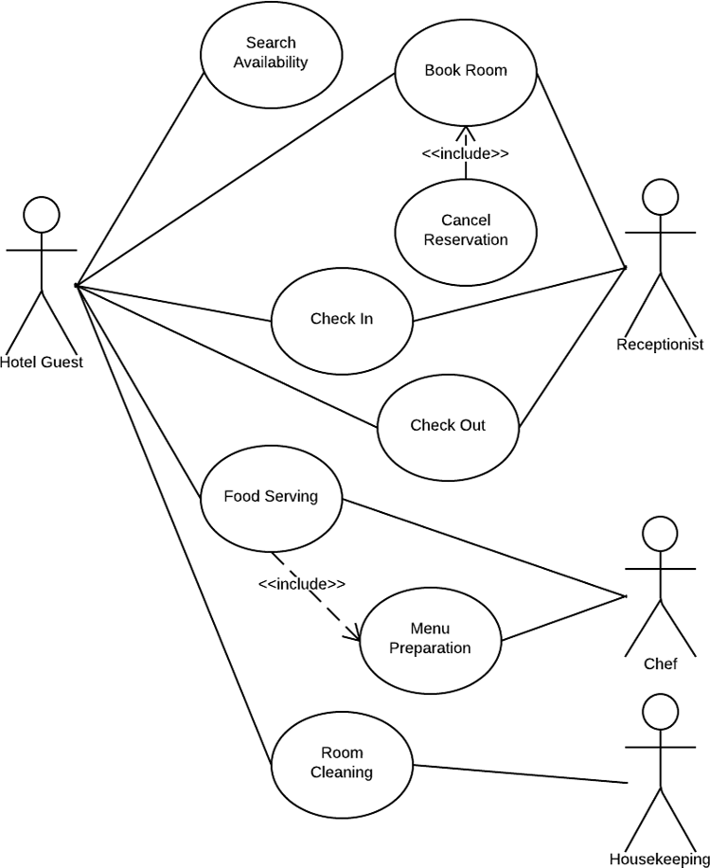

Figure 1: Use Case Diagram

**5.4 ER Diagram**

An Entity-Relationship (ER) diagram is a visual representation of the relationships among entities in a database. It typically includes entities (such as people, objects, or concepts), attributes that describe these entities, and the relationships between entities. ER diagrams use symbols to represent entities, attributes, and relationships, helping to visualize the database structure and design.

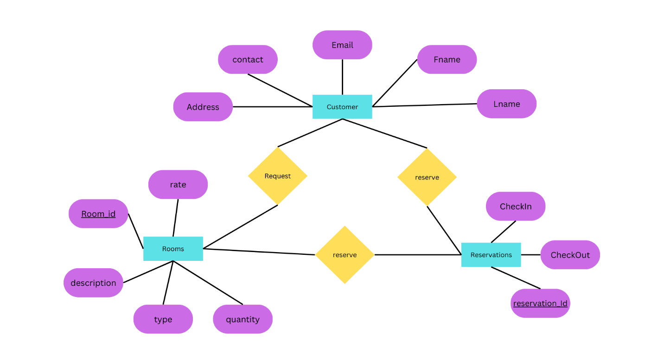

Figure 2: ER Diagram

**5.5 Data Flow Diagram**

A Data Flow Diagram (DFD) illustrates how data flows through a system, showing the processes, data stores, and external entities that interact with the system. It consists of processes that transform data, data stores that hold data, data flows that represent the movement of data between processes and stores, and external entities that interact with the system. DFDs are useful for understanding system requirements and designing new systems or improving existing ones.

**5.5.1 Zero Level DFD**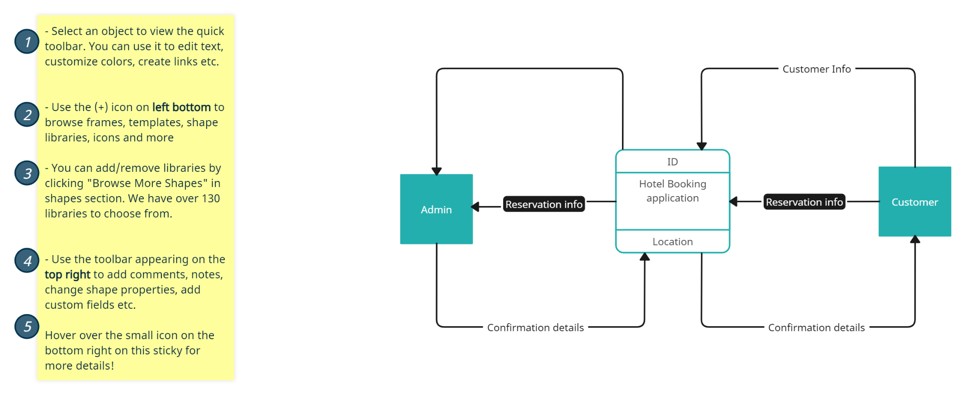

Figure 3: Zero Level DFD

**5.5.1 First level DFD**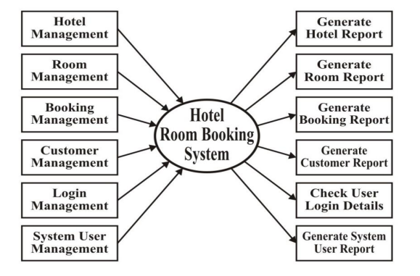

Figure 4: First Level DFD

**5.5.1 Second level DFD**

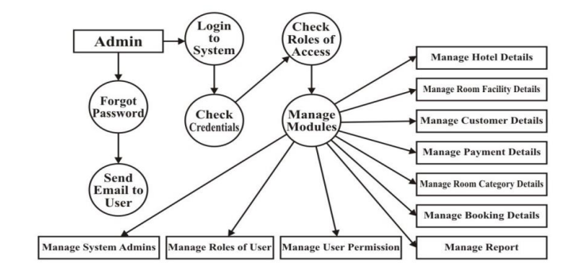

Figure 5: Second Level DFD

**5.6 Design Goal**

Our design goal for the e-commerce web app is to forge a seamless and user-centric digital shopping experience. Prioritizing simplicity and functionality, we aim to create an intuitive interface that enhances user engagement and satisfaction. Streamlined navigation is a focal point, ensuring users can effortlessly explore products and find relevant information. The design will prioritize enhanced product discovery through visually appealing displays, personalized recommendations, and a well-organized product catalogue.

Our goal is to captivate users' interest and facilitate informed decision-making. The checkout process will be a frictionless journey, emphasizing clarity, multiple payment options, and transparent communication. Ensuring a responsive interface across devices is paramount, guaranteeing a consistent and enjoyable experience for users on various platforms.

Performance optimization, including swift loading times and efficient interactions, is integral to sustaining user engagement. Aesthetic considerations will contribute to the overall user experience, employing visually pleasing design elements that align with our brand identity. In conclusion, our design goal is to amalgamate functionality and aesthetics, creating an e-commerce platform that not only meets user needs but also exceeds expectations, fostering customer satisfaction and loyalty.

**CHAPTER 6**

**Testing**

Testing is a crucial phase in the development of a hotel booking application to ensure that it functions as expected, is user-friendly, and meets the specified requirements.

**6.1 Testing**

**Functionality Testing:** Checked if all features such as room search, booking, and payment processing work as expected.

**Usability Testing:** Assessed the user interface for ease of use and navigation.

**Compatibility Testing:** Ensured the application works correctly on different devices and browsers.

**Performance Testing**: Checked the application's response time and stability under varying loads.

**Security Testing**: Checked for vulnerabilities and ensured user data is protected.

**Regression Testing:** Ensured that new updates did not adversely affect existing functionality.

**6.2 Test Results**

**Functionality**: All critical functions such as room search, booking, and payment processing were found to be working correctly.

**Usability**: The user interface was intuitive, and users were able to complete tasks without difficulty.

**Compatibility:** The application was tested on multiple devices and browsers, and no compatibility issues were found.

**Performance:** The application responded well under normal and peak loads, with acceptable response times.

**Security:** No major security vulnerabilities were found, and user data was protected.

**Regression**: New updates did not introduce any regressions, and existing functionality remained intact.

**6.3 THE STEPS IN THE SOFTWARE TESTING**

The steps involved during Unit testing are as follows:

a. Preparation of the test cases.

b. Preparation of the possible test data with all the validation checks.

c. Complete code review of the module.

d. Actual testing done manually.

e. Modifications done for the errors found during testing.

f. Prepared the test result scripts.

**SCREEN SHOTS OF HOTEL BOOKING APPLICATION**

**Home page:**

The hotel booking application's home page features a user-friendly interface, allowing users to easily search for and book rooms, view hotel information, and manage their bookings efficiently.

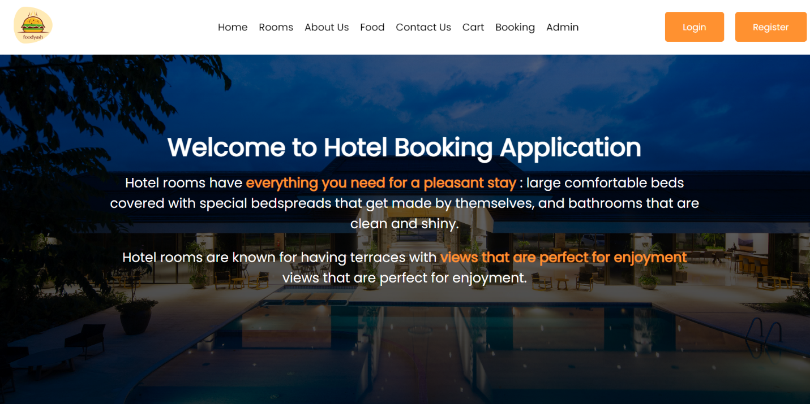Figure 6: Home Page

**User Login page:**

User login to his/her account by filling username/email id with password.

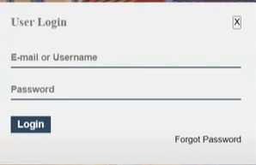

Figure 7: User Login Page

Figure 8: User Registration Page

**Room availability check:**

The room availability page displays available rooms for selected dates, allowing users to choose and book accommodations.

Figure 9: Room Availability Check

**Available Rooms:**

Based on searching criteria

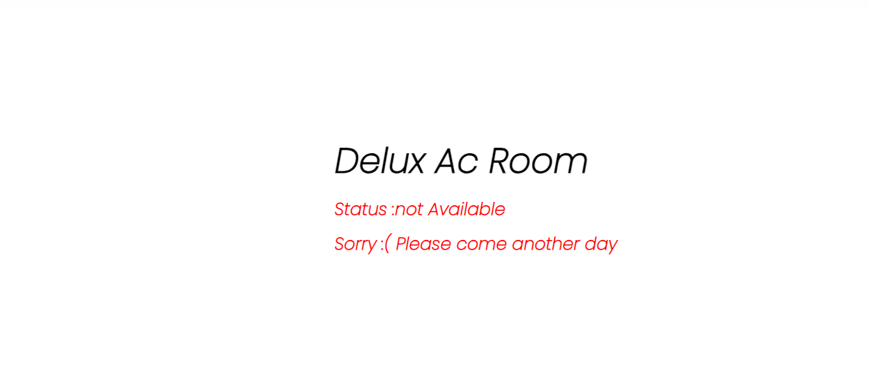

Figure 10: Delux AC Room

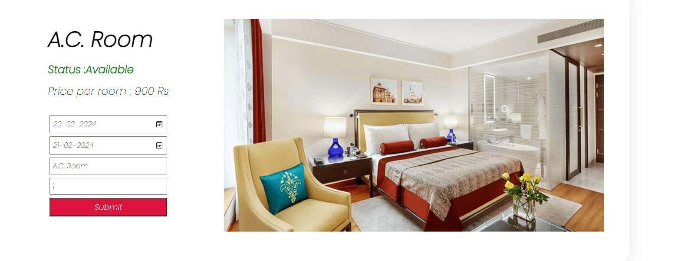

Figure 11: AC Room

Figure 12: Non-AC Room

**Booking page:**

The hotel booking application's room booking page allows users to select dates, room type , necessary user details , and make reservation securely .

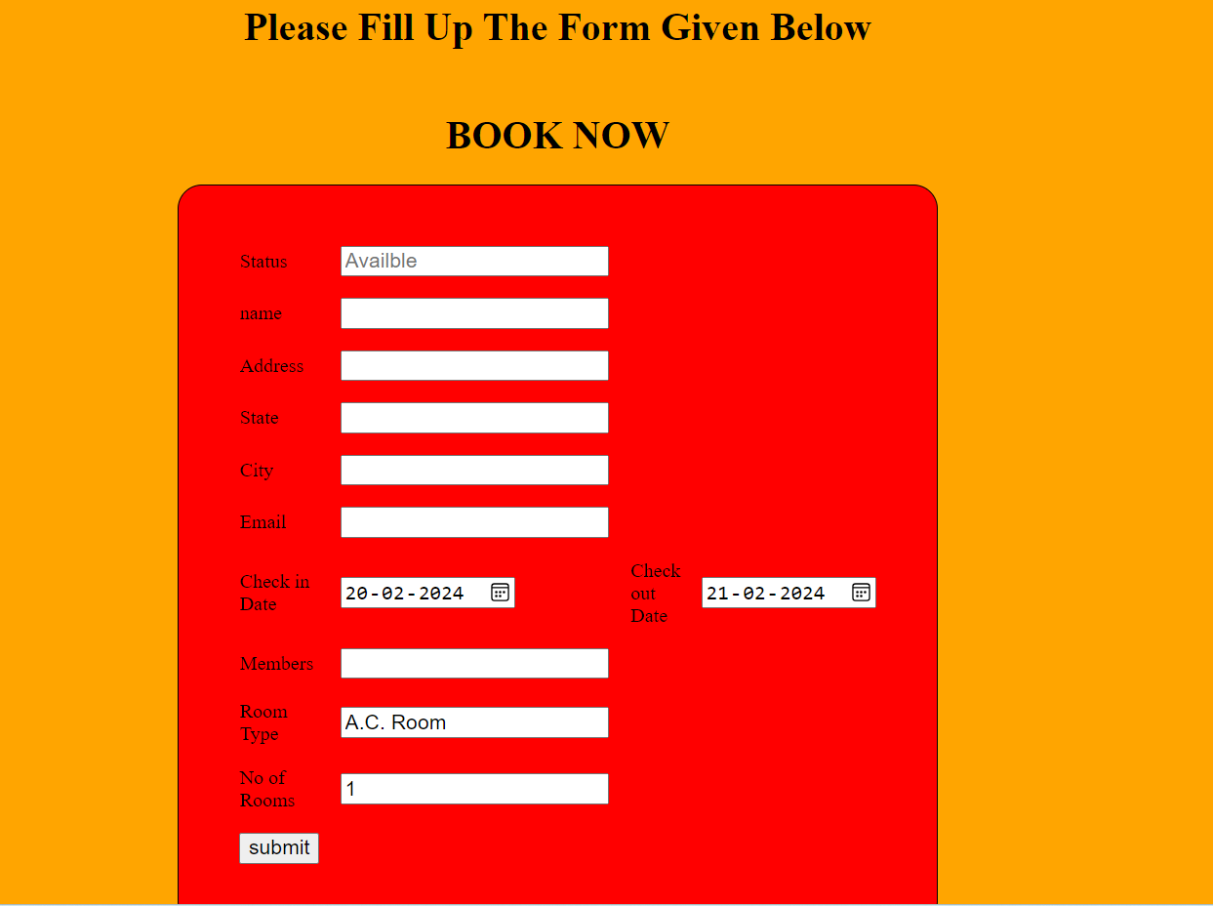

Figure 13: Booking Page

**Admin Login Page:**

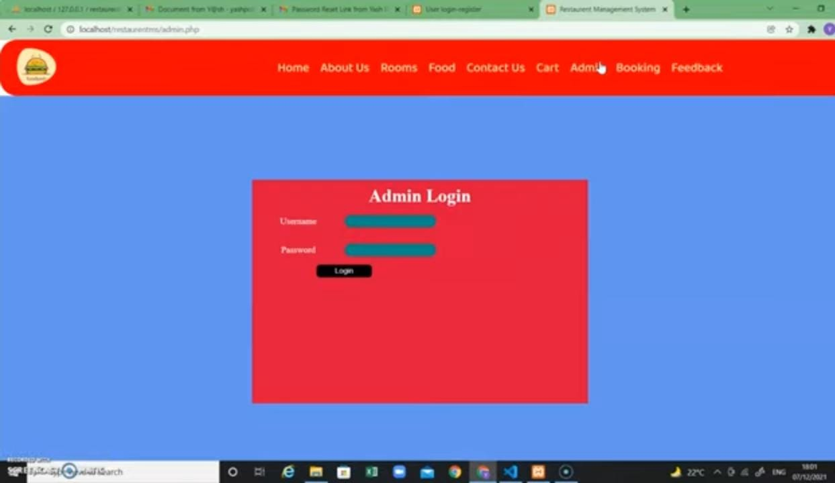

Figure 14: Admin Login Page

Figure 15: Food Page

**Add To Cart Page:**

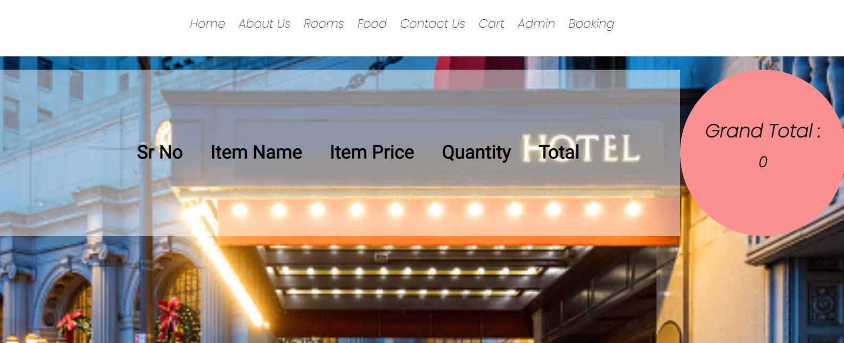

Figure 16: Add to Cart Page

**CHAPTER 7**

**CONCLUSION**

In conclusion, the hotel booking application offers a user-friendly platform for booking rooms within a specific hotel. By focusing on a single hotel, the application provides a tailored and personalized experience for users, streamlining the booking process and enhancing user satisfaction. Its intuitive interface, real-time room availability, and secure payment processing make it a valuable tool for both customers and hotel staff. The application's performance, scalability, and reliability ensure a seamless experience even during peak usage periods. With its robust functionality and user-centric design, the hotel booking application is poised to make a significant impact in the hospitality industry.

**FUTURE ENHANCEMENT**

Future enhancements for the hotel booking application include integrating AI chatbots for instant customer support, developing a dedicated mobile app for broader accessibility, and incorporating personalized recommendations based on user behaviour. Additionally, improving analytics capabilities, expanding social media integration, and ensuring accessibility features for all users are key priorities. These enhancements aim to enhance user experience, increase customer engagement, and drive further growth in the hospitality industry.

**CHAPTER 8**

**REFERENCES**

* <https://www.w3schools.com/php/>
* <https://www.javatpoint.com/html-tutorial>
* <https://www.canva.com/graphs/er-diagrams/>
* <https://ijcrt.org/papers/IJCRT22A6549.pdf>
* <https://github.com/>
* <https://www.tutorialspoint.com/java/>
* <https://www.geeksforgeeks.org/php-tutorial/?ref=lbp>